Software Development:

Object Orientated Programming

DH3C 35

Assessment –
Outcome 4.

Student |  | Martin Naismith
I.D. |  | 1013403
Date |  | 20/11/12
 | Pass |  |  | Fail |  | Remediation
Tutor |  | Stewart McDonald

INSTITUTE OF COMPUTING

Glencaldy Learning Centre
Recording System

User Manual
Version 1.0

Prepared by: Martin Naismith
Student ID: 1013403
Date: 10th February 2013

Table of Contents

Introduction
Topics Discussed in this Manual 1-i
Who Should Use This Manual 2-ii
Other Support Services 3-ii
Chapter 1
Installing, Logging On, Accessing the System
System Requirements 4-1
Installation Instructions 5-1
Logging On To/Accessing System 6-2
Chapter 2
Using the System, Centre Member Accounts
Staff Notes 7-1
Centre Member Account 8-2
User Manual 9-2
Logging On To /Accessing The System 10-3
The Search Menu 11-5
Chapter 3
Using the System, Staff Member Accounts
The User Menu 3-3
The Stock Menu 3-6
The Loans Menu 3-10
Chapter 4
Using the System, Management.
The Management Menu 4-2
Appendix A — Error Messages
Handling Error Messages A-1

Introduction
The Glencaldy Learning Centre Recording System is to help staff track centre members and their borrowed items from the centre and to provide an inventory of all items held as stock in the centre. The Glencaldy Learning Centre is a service available to the public, where they can register and use the library facilities. The centre holds items in book, journal, video and compact disc format. If a member wants to borrow the item they can be registered as a full member. A casual member can only use the item inside the centre. Staff members can also borrow items for their use.

Additionally, there are management functions which will be enhanced to provide management with additional information. The system is menu driven and with training will be easy to navigate to achieve the results required by the user. Staff and centre members can use the system to identify items to use in the centre or to borrow on loan.

When a new user or new staff member are registered onto the system they are provided with a userID, logon name and password. When a user or staff member enters the centre their login is validated and registered in the login records. All users can search using various search criteria through the catalogue of items.

Topics Discussed in this Manual

This manual describes how to use the Glencaldy Learning Centre Recording System. The following chapters are included:

- Chapter 1 — Walks you through the system requirements, set-up and installation of the software with step by step instructions. Details the initial administrator logon and setup of user accounts.
- Chapter 2 — All users, Logging on, Administering your user account. Viewing your current items on loan. Searching for items from the Learning Centre.
- Chapter 3 — Staff Administration Tools, Creating and Editing user accounts, Adding Stock Items and Editing details, Creating Loan and Returning Items borrowed by Centre Members.
- Chapter 4 — Management Administration Tools, Reports and listings for Centre Members, Stock Items and Items on Loan, Opening Times and User Logins.

Who Should Use This Manual

This manual is used by different groups in different ways. This section describes how you should use the manual and what sections you should use. See the following list for guidance:

- Public Members using the system. — This manual is not intended to be handed out to the Centre Members but the relevant section i.e. Chapter 2 is to be copied and handed out as instruction for use in the centre only and returned on leaving. The Members will eventually be able to use the system without instruction as the system will be intuitive and easy to navigate once used a few times.
- Staff members using the system. — This manual should be read while using and familiarising yourself with the system, it can be referred to while practicing with the test data. Staff are expected to be fully conversant with the system while dealing with Centre Members .
- Management using the system. — There is additional functionality on the system to provide you with reports and inventories useful for Centre Management and record keeping.

Other Support Services

Other support services available for this system are listed below. Please make use of these services after you have tried to answer your questions using the existing documentation and help available within the system. We will install the system for you if you are not sure about the following procedures. We will return your email request within 1 hour in the working day, we are available from 09:00 to 17:00. Our technical support may call depending on the problem so include your phone number on the email please.

Support Service | Description | Access Information
Library Builder Services | Software Developer | techsupport@lbs.co.uk
Library Repairs | 24 Hour Assistance | martinnaismith@ovi.com

Chapter 1

Installing, Logging On, Accessing the System

This chapter describes how to install Glencaldy Learning Centre Recording System on each supported platform and how to logon to Glencaldy Learning Centre.

System Requirements

The computer system requires an operating system of Microsoft Windows XP or higher, with at least Pentium 4 or AMD Athlon main processor and 1Gb of physical memory. The operating system has to have the Java Virtual Machine environment installed to obtain the latest version of this visit the following website and follow the instructions on the JVM installation.

http://www.java.com/en/download/index.jsp

Once JVM is installed follow these instructions.

Installation Instructions

To install this system, follow these steps:

- Create a directory on your hard drive (normally C\: ) called Glencaldy. Insert the provided CD into your CD drive and copy the file [GLENCALDY.EXE] to the [C:\Glendaldy] directory on the hard drive.
- Once the file is copied a shortcut can be set onto the desktop by right clicking the GLENCALDY.EXE file and selecting [CREATE SHORTCUT] or [SEND TO DESKTOP]. The created shortcut can be cut and pasted to the desktop or dragged onto the desktop by clicking and holding.
- Once the shortcut is copied on the desktop to [OPEN] the Glencaldy Learning Centre Recording System, double click the shortcut in the normal manner or right click and select [OPEN].
- If you are presented with the login screen as below, well done you have successfully installed the system. If not send an email to the support service noted above.
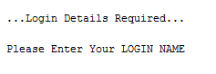

Logging On To/Accessing System

To log on to/access the system, follow these steps

- The system is installed with a default account for the first running of the system. This account should be changed to the details of the system administrator or the IT system technician details.
- Use the following details to login using lowercase only –
LOGIN NAME = admin press[ENTER]
PASSWORD = password press[ENTER]
As shown in the following screen.
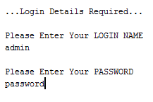
Figure 1-1: Enter the default account login details
Each user and item in the system is allocated a unique number for future reference. The users are allocated numbers from 101, items in the centre are allocated a number from 1001. The default account is numbered as 101. This number should be noted.

- On successful login the following screen is presented for the Staff Main Menu.
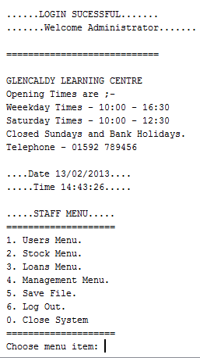
Figure 1-2: Staff Main Menu after login.

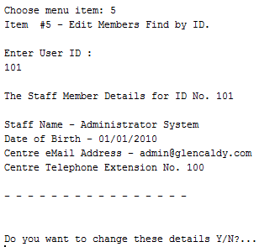
- The first task is to change the default account to your system administrator details.
Type [1] and press [ENTER] to access the ‘USER MENU’, in the list on the user menu item ‘5’ is the ‘Edit members find by ID’. Type [5] and press [ENTER] to use this function.
When asked for the User ID, Type [101] and press [ENTER].
The screen below should be displayed, type [Y] and [ENTER].
Now enter your own administrator details to change the default account.
Figure 1-3: Default ‘Administrator’ Account Details.
You will be asked for NEW First Name, NEW Surname, NEW Date of Birth, NEW Login Name, NEW Password, NEW eMail address, New Centre Tele Extension and finally if the account is a ‘LIVE’ account, type [Y] and press [ENTER]. You have now changed, overwritten the default administrators account. Ensure your details entered are correct by checking, on return to the USER MENU after entering your details you can select item ‘5’ again to display the details for user ‘101’ again. They should be your new details, type [N] if they are correct, you will be returned to the USER MENU .
- You can now return to the STAFF MENU by entering [0] (number zero), again enter [0] to close down the system. Only a member of staff can close down the system, if a Centre Member (not staff) is logged in on a machine their only option is to log out, they cannot close the system down.

Chapter 2

Using the System, Centre Member Accounts

Staff Notes

The following pages are for the use of all the Centre Members as a hand out to assist them while using the system in house. There are common tasks included in this section that all system users will require. It is useful for the staff to be familiar with functions available to Centre Members therefore they should read through this section.

Items included in this section are ;-

Logging on
The Search Menu
Editing Personal Details
View Loans History

Copy the following section of Chapter 2 as a separate handout for use by the public in the Centre.

Glencaldy Learning Centre
Recording System

Centre Member Account

User Manual
Version 1.0

Logging On To /Accessing The System

On completion of your registration by a member of staff you will be able to use the search facilities at the Glencaldy Learning Centre using one of the computers allocated for member use. These will be identified to you when registering your details.

When starting to use a computer it should be already started by a member of staff and the desktop should be displayed. If the Glencaldy learning Centre Records System is running but not displayed on the screen, a task will be sitting on the task bar, i.e. minimised. Click this task and the centre login will be shown. If the system is not running there will be an icon on the desktop for the Glencaldy Learning Centre. Double click this icon to start the system in the usual manner. You will be presented with the following request for your login details.

On entering your registered details you will be given access to the system. You must enter the details exactly as they were registered including the upper and lower case letters, as the login is case sensitive.

LOGIN NAME = [your login user name] press[ENTER]
PASSWORD = [your password] press[ENTER]
As shown in the following screen.

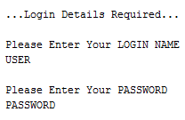

On successful login you will be presented with the following screen if you are a FULL Centre Member, providing information about the centre times and the USER MENU.
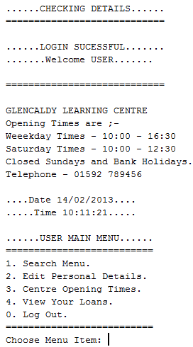

An hourly user to the centre has a similar display however item ‘2. View Your Loans.’ is not available, as hourly users cannot remove materials from the centre for loan.

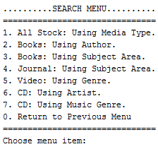

Accessing The Search Menu

At the ‘Choose Menu Item: ‘ type [1] on the keyboard and press [ENTER] to access the SEARCH MENU. The following is displayed.

The Search Menu

Item 1. All Stock: Using Media Type.

At the ‘Choose Menu Item: ‘ type [1] on the keyboard and press [ENTER] to access Item 1 the following screen is displayed.

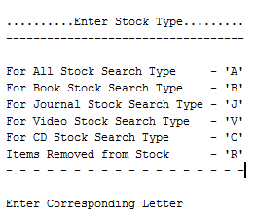

At the cursor ‘Enter Corresponding Letter’ type the letter for the type of search you want to produce.

‘A’ – Produces a list of all items in the library, THIS SHOULD BE AVOIDED, as it will produce rather a large list.

‘B’ – Produces a list of all the BOOKS in the library.

‘J’ – Produces a list of all the JOURNALS in the library.

‘V’ – Produces a list of all the VIDEOS in the library.

‘C’ – Produces a list of all the COMPACT DISCS in the library.

‘R’ – Produces a list of all the REMOVED STOCK in the library. Possibly the book you are looking for has been damaged and is awaiting repair.

On completion of the list display you will be returned to the SEARCH MENU.

Item 2. Books: Using Author.
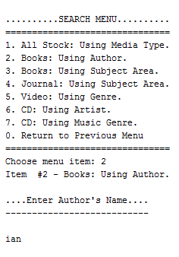

At the ‘Choose Menu Item: ‘ type [2] on the keyboard and press [ENTER] to access Item 2 the following screen is displayed.

You need not enter the full authors name at the cursor after ‘Enter Authors Name’. If you can only remember the first name or a part of the name, this is all that needs to be entered. The search is not case sensitive.

In the example ‘ian’ is intended to be the first name but could be part of a name. The search produces books with these three letters in this order in the name of
the author. i.e. Brian Keene or Ian Rankin.

Item 3. Books: Using Subject Area.

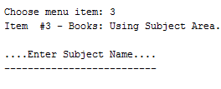
As above the full subject name does not need to be entered however the more specific you make your entry the more specific the search. If the search is too specific it could return ‘No Items Found’. So use this search with care.

Item 4. Journal: Using Subject Area.

As Item 3. The full subject name does not need to be entered only a part. So if ‘sport’ is entered the search will return all subjects containing the letters ‘sport’ so ‘motorsport’ will be retuned along with ‘fitness’ and ‘cycling’ journals, etc..

Item 5. Video: Using Genre.

As Item 3. The full subject / genre does not to be entered. If you are looking for an age certificated video i.e. ‘PG’ or ‘12’ enter this and the search will return the videos for that age group. Try not to mix genre type and age if you do use age last. Mixing a word and number is a bit more specific than a single word. So don’t be too specific or the search will produce no returns.

Item 6. CD: Using Artist.

As Item 3. The full artist name, however the more specific you make the search the less results will be returned.

Item 7. CD: Using Music Genre.

As Above the search will work on a part of the name.

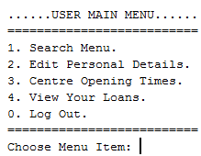
Item 0. Return to Previous Menu.

Return you back to the USER MAIN MENU. As shown.

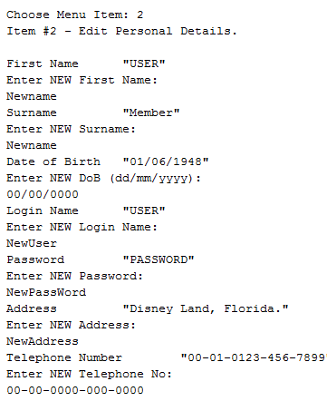
User Menu Item 2. Edit Personal Details.

This function allows you to change any details held on record, i.e. if you change your address or password, etc..

As shown an example of the order of these items to change is shown here.

If no entry is made you will be asked to make an entry again, this will repeat until a valid entry is made.

Once all details have been entered you will be returned to the USER MAIN MENU.

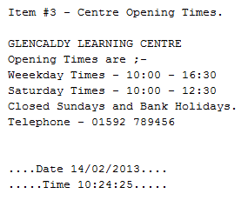

User Menu Item 3. Centre Opening Times.

The details as shown,

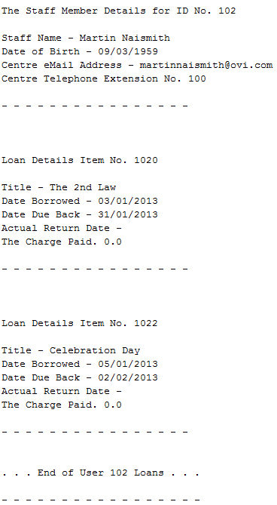

User Menu Item 4. View Your Loans.

The details of your current items, books, journals, videos and cds that you have on loan. An example is shown.

Once you are finished with the search functions, please remember to logoff the system to allow access for the next user.

When using the Glencaldy Record System there will always be a member of staff to hand to assist in any way. Please do not hesitate to ask, the staff are only too pleased to help with your request.

Chapter 3

Using the System, Staff Member Accounts

This chapter is for the use of staff of the Glencaldy Learning Centre. They describe the use of the system for administering the stock of the Glencaldy Learning Centre.

Items included in this section are ;-

Staff Administration Tools
Search Tools ( also see Chapter 2 )
Creating and Editing user accounts
Adding Stock Items and Editing details
Creating Loan and Returning Items borrowed by Centre Members
On successful login you will be presented with the following screen for the Staff Member. Providing information about the centre times and the STAFF MENU.

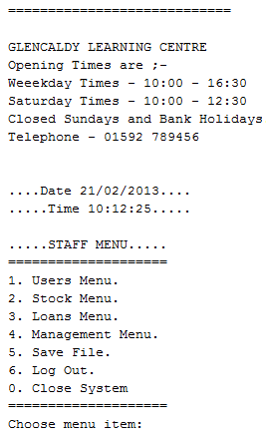

Fig. – Staff Menu after Logon.

Each item on this menu directs you to a more detailed menu with functions for that selection. Enter the corresponding number for the menu you wish to select. We will step through each of these menus in turn describing the use of each function in the system. It should be quite intuitive in use and once you are familiar with the system you should find it quick to access the information you require.

You will note there is an item ‘0’ to ‘Close System’, this function is only available to Staff and is carried out at the end of the day for all systems running. When leaving a console you are merely required to LOG OUT of the system to ensure your details are not compromised.

Accessing The User Menu

At the ‘Choose Menu Item: ‘ type [1] on the keyboard and press [ENTER] to access the USER MENU. The following is displayed.

The User Menu

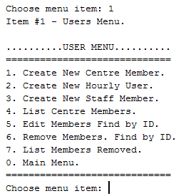
This menu provides you with all the functions to create, list, edit and remove any type of centre member. These functions are for senior members of staff or with the assistance from a senior member as sensitive data is stored on the system and data protection laws apply to the use of the data stored.

You should know your responsibilities before accessing any of these functions.

Item 1. – Create New Centre Member

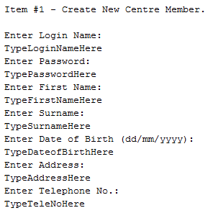
You will be asked to enter each item shown here for the new member. This member is able to remove items from the centre on loan. The details you enter for a centre member must be verified with two forms of identification that are dated for the current month.

Type the user details at the cursor, noted by TypeLoginNameHere etc..

These details must not be written down. Do not worry if there are mistakes on entry of the data as there is an opportunity to check and change the users account information.

On completion of entry of the information you will be returned to the USER MENU.

Item 2. – Create New Hourly User

The details required for the hourly use are the same as the centre member above, however the hourly user is not permitted to remove items for the centre on loan.
Item 3. – Create Member of Staff
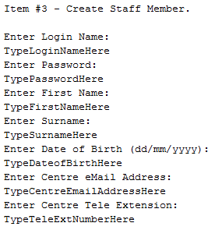
As above, you will be asked to enter each item shown here for the new staff member. Staff are also able to remove items from the centre on loan.

These details must not be written down. Do not worry if there are mistakes on entry of the data as there is an opportunity to check and change this staff account information.

Item 4. – List Centre Members

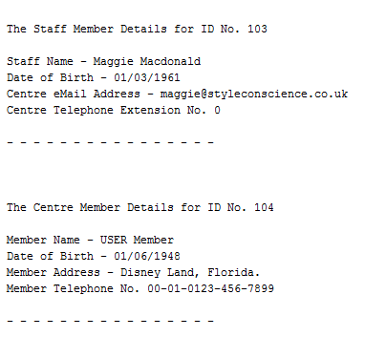
The list centre members function does what it says on the tin. A full list of all active accounts for centre staff, full centre members and hourly members in member ID numerical order.

The details provided are generally intended for contact information, the username and password are not provided in this listing. See example listing.

Item 5. – Edit Members Find by ID.
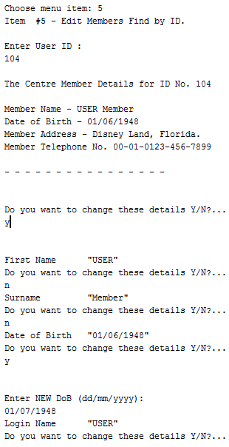
This function allows staff to edit the full details for a user’s account. The account is identified by the users ID number which is entered at the cursor after selecting this function from the menu.

The users account details are displayed for confirmation and you are asked to enter ‘Y’ for yes or ‘N’ for no. If you enter ‘Y’ the first of the account details is displayed and again you are asked to confirm if you wish to change the details by entering ‘Y’ or ‘N’.

If you enter ‘N’ the details are skipped over and the next item of information is displayed. If you enter ‘Y’ you are asked to input the new information, there may be a format that the information is required to be in. This is shown in the instruction to ‘Enter NEW’ data the format is shown in brackets.

The last piece if information you are shown is the account status, this will normally be shown as ‘Live Account’.
You can change this and you are asked
if you want to ‘Deactivate account. (Y/N)?’.
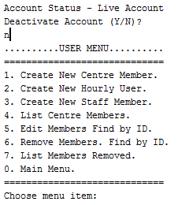
In normal circumstances this answer will be
‘N’ – no. However if the centre member is to be taken off the system if they are moving away from the area, or no longer wish to use the centre or in extreme circumstances, they are to be banned from using the search system due to abuse of the system or of the centre facilities then this can be answered by ‘Y’ yes. This account is now disabled and the user can no longer login. The account information is held on record as there may be need to locate the user in future for unreturned loans. After entry of the account status you are returned to the USER MENU. As shown.
Item 6. – Remove Members Find by ID.

As above the member account can be deactivated directly by this function. Again the member account details are shown and you are asked for confirmation if this is the account to be removed (deactivated), the ‘Y’ yes or ‘N’ no answer is required by you to be entered at the cursor. A confirmation of this account status is shown on completion of this task. You are then returned to the USER MENU.

Item 7. – List Members Removed.

As Item 4 this function lists the member accounts, the difference is that these are accounts that have been disabled for whatever reason. These accounts can be made active again in the Item 5. – Edit Members Find by ID above. The last detail on the edit function is to set the account status, the account can be set to active.

Item 0. – Main Menu.

Entering ‘0’ at the cursor returns the user to the MAIN MENU.

The Stock Menu

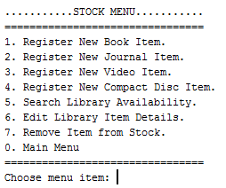
This menu provides you with all the functions to register and edit books, journals, videos and cds on to the learning centre stock database.

There is a useful link to the Search Menu at item 5. It is normal that an item number is checked prior to carrying out some editing or to remove the item form stock. The search menu was covered in Chapter 2.

The ‘Remove Item from Stock’ function
must be sanctioned by a senior
member of staff.
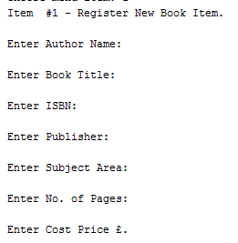
Item 1. – Register New Book Item.

This function requires information to be entered for a new book stock item. The information required is shown adjacent. Do not be concerned with entry errors as they can be checked and amended in the function to edit library item details.

On completion of the data entry a confirmation will be shown and the Item number will be displayed for noting the reference in the book.

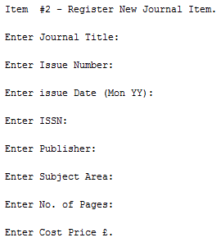
An example of the detail required to register a book is shown adjacent.

An example of the registration confirmation for a CD is shown on the next page

Item 2. – Register New Journal Item.

As above the details for the journal are entered and the item No. is displayed on completion.

An example of the detail required to register a journal is shown adjacent.
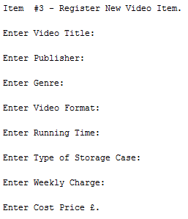
Item 3. – Register New Video Item.

As above the details for the video are entered and the item No. is displayed on completion.

An example of the detail required to register a video is shown adjacent.

An example of the registration confirmation for a CD is shown on the next page.
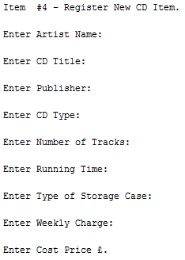
Item 4. – Register New Compact Disc Item.

As above the details for the compact disc are entered and the item No. is displayed on completion.

An example of the registration confirmation is shown below.



Item 5. – Search Library Availability.

The search function directs the user to the Search Menu.
The search menu was covered in Chapter 2.

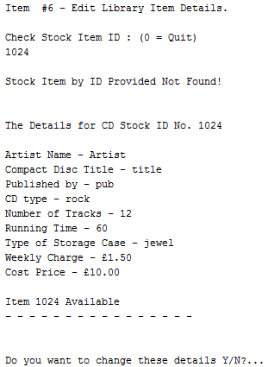

Item 6. – Edit Library Item Details.

You will be required to know the item number prior to using this function. Use the search menu as noted above to find the item number if not known.

On entry of the item number the item details are shown and confirmation is required to change the details.
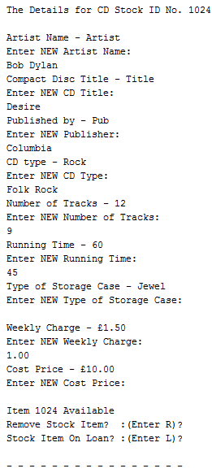
Item 6. – Edit Library Item Details.
Continued...

The existing details are displayed and you are asked to enter new details. If the details do not require to be changed you can hit the return and the existing data is used, as in ‘Storage Case type’, ‘Cost Price’ and ‘Availability’. To change the details type the new details at the cursor.

On completion of the entry of new data you will be asked to update the item status, this is either 'Available', 'On Loan' or 'Removed' depending on current status. On updating or not of the status you are returned to the STOCK MENU.

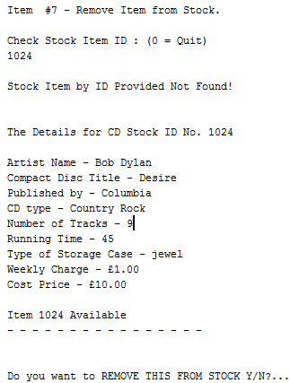

Item 7. – Remove Item from Stock.

You will be required to know the item number prior to using this function. Use the search menu as noted above to find the item number if not known.

On entry of the item number the item details are shown and confirmation is required to change the details.


Once items are removed from stock they will still be displayed on the stock list to show the status of the stock item, as shown. The item may return back to stock, this can be done by editing the stock details as above.

The Loans Menu

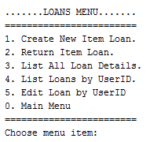
This menu provides you with all the functions to create and administer all the details of an item borrowed, all books, journals, videos and cds from the learning centre stock database.

When attending to the front desk at the centre you will most likely be using this part of the system. This is the main functionality of the library, previous sections were only dealing with storing and retrieving data about members or items in the centre system. This section brings the two parts together.

When creating a loan the item is stored against the 'Users Loan Account' which can keep 6 items on loan. They are allowed to borrow each item for 28 days after which time a charge is levied against their account, as the item is overdue. This charge of overdue items will be carried out manually at present, however in future releases the function will be built into the system and added to this menu to list loans overdue.

Item 1. – Create New Item Loan.

When a member wishes to remove an item from the centre stock for loan they will bring the item to the front desk where a member of staff must book the item out on loan against the centre members account. When using this function it follows the normal course of the loan transaction. You will enquire the members surname the result should display their details which you will confirm with them. If there are more than one centre member with that particular surname you will be given the choice to confirm the displayed details or move on to the next. If the surname cannot be found for whatever reason the system will ask for the members Glencaldy Centre ID Number to find the member.

Once the member has been found and confirmed, their current items on loan are displayed with the due date for you to check. The system then asks for a key word in the title of the item and the type of item to be borrowed, it then does a search for this item and displays the details if found. The full details and the status are shown for you to confirm. The details of the loan to be registered are then displayed for you to confirm. If all the details are correct and the loan is created a confirmation of the item being on loan is displayed. At any point in the process where you are required to confirm the details, you can exit the creation of the loan by typing ‘N’ at the confirm questions. Or at the find item menu where you can enter ‘0’ to ‘Quit Loan’.

An example of this function is show on the next page.
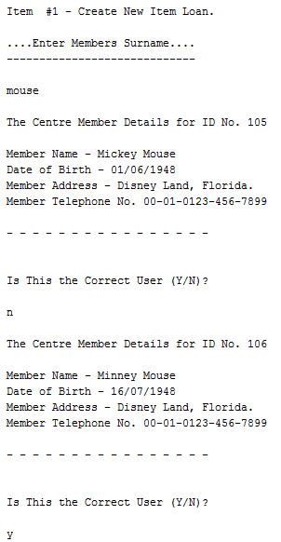
Enter Centre Member’s name, not case sensitive.

Centre Member’s details displayed

Confirmation Required - No

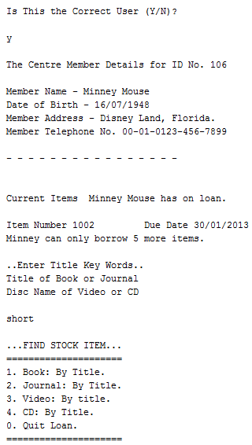
Next Centre Member with this surname details displayed.

Confirmation Required – Yes

Centre Member for the loan.

Current loan information displayed

Key word from item title required

Menu displayed for item type to be set on loan. Continued over……
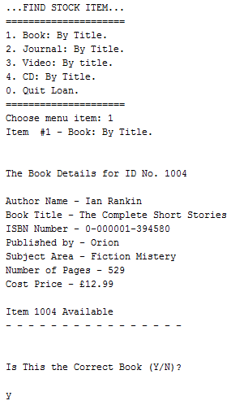

Select item type from list and enter the appropriate number at the cursor. Or Quit by entering zero.

The item was a book

The details are displayed to confirm it is the correct item being loaned out.

Confirmation of this is required.

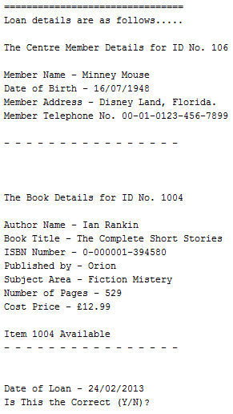

The full loan details are displayed for confirmation

Centre Member details.

Loan item details.

Date for start of loan.
Confirmation of this required.

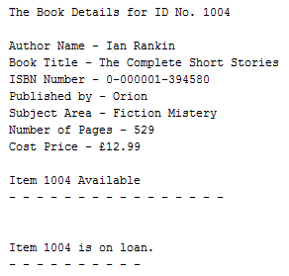
Adjacent is confirmation of the item on loan.

You have now completed the recording of the stock item on loan to the centre members loan account. You will be then be returned to the LOAN MENU.

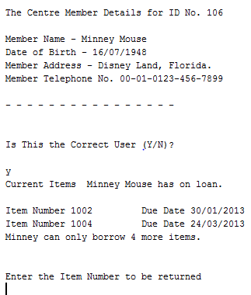
2. – Return Item on Loan.

As with Item 1 you will be asked for the members surname to search for their details. Again on confirmation of the member, their current loan items will be displayed along with the due date.

The Item returned is checked against the list and the number for that item is entered at the cursor. The details for the item will be displayed for you to confirm. On doing this a confirmation of the status of the item is displayed as being back in stock. An example of this process is shown on the next page.

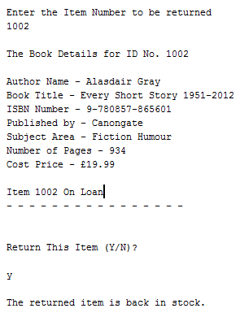
The example shows the item number 1002 being returned to stock by member Minney Mouse.

On completion of this process you will be returned to the LOANS MENU.

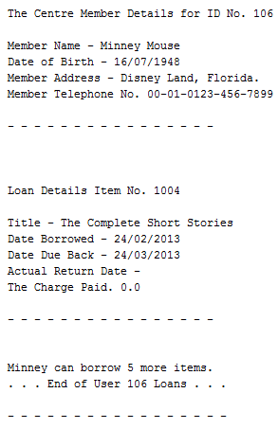
Item 3. – List All Loan Details.

This function creates a list of all members loans ordered by member ID with their associated loan items. It also details how many further items they can borrow.

As shown here for Minney Mouse, she only has one item on loan and can borrow a further five items.

On completion of this process you will be returned to the LOANS MENU.
Item 4. – List Loans by User ID.

As above this function list the loan details. However you are asked for the centre members ID number. On completion of this process you will be returned to the LOANS MENU.

Item 5. – Edit Loans by User ID.

Still to be implemented. Planned for next release of the system.

Chapter 4

Using the System, Management.

This chapter is for the use of management staff of the Glencaldy Learning Centre. They describe the use of the system for monitoring and reporting on members and stock of the Glencaldy Learning Centre.

Items included in this section are ;-

Current Functions Edit Opening Times
List Logins

Future functions List Overdue Items
List Od History by User ID
Issue Od Letters by User ID
Check Fees Paid for Od Items

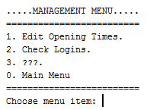
The Management Menu

This menu is partially complete, it is intended to allow the management to check the overdue items and issue letters to centre members who have outstanding items. It will have functionality to track fees paid by the members and a tally of all fees to identify members continually being late on returns.

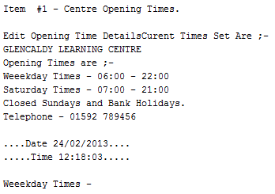
Item 1. – Edit Opening Times.

This function stores the opening times for the centre. It allows the management to make alterations to the stored information. The format should be kept the same as the existing text as this is only stored as a string of text. It is recommended to use 24hour clock times as shown.

At the cursor enter the times to be open on weekdays, on entering this the Saturday times are next to be entered. You can skip entry by hitting the return key prior to putting any data in at the cursor. On completion of new data entry the new times are displayed and you are returned to the MANAGEMENT MENU.
Item 2. – Check Logins.
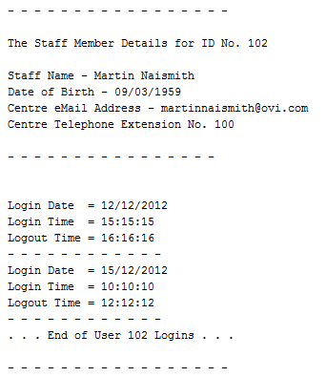
This function allows the management to check all the centre members and staff logins and logouts on the system. It can be useful as a reference tool.

If a member is still logged in the Logout Time on the last record will be black awaiting their logout time being registered.

On completion of this process you will be returned to the MANAGEMENT MENU.

Item 3. – List Overdue Items.

Still to be implemented. Planned for next release of the system.

Item 4. – List Overdue History by User ID

Still to be implemented. Planned for next release of the system.

Item 5. – Issue Overdue Letter by User ID.

Still to be implemented. Planned for next release of the system.

Item 6. – Check Fees Paid for Overdue Items.

Still to be implemented. Planned for next release of the system.

Appendix A — Error Messages

This appendix helps you interpret the messages the system displays to alert you of errors. Sometimes, these messages occur when erroneous data is entered. Other times, these messages occur when there is no match to data in the database.

This appendix describes the meaning of each error message you might encounter and how to remove the error condition that caused the message. In most circumstances if the function you are using malfunctions, you will be returned to the menu that the function you were using originated from.

It will help to improve the system if there is a function you are not satisfied with, due to errors occurring, is reported to the help desk noted on ‘Page ii’ of the ‘Introduction’ in this manual.

Most errors will be generated by the system not finding an instance of the search item in the category being searched. It would help to eliminate errors if a list of your categories used for searching are noted on a distribution sheet for use by users.

Handling Error Messages

Message | How to Remove the Error Condition
Please Enter a Valid Number! | Enter as number associated with the menu items.
Please Retry the Function! | Enter zero to quit, if not already back to menu.
…. Not found! | The entry does not match an item in the database.

